Programming Note: This 'How to Use This Module' page is for Print only. The programmed Adapt 'How to Use This Module' page should mirror the Figma template.

How to Use This Module
This module is divided into chapters and sections. Each chapter begins with a list of Learning Objectives (LOs). Medical terminology is highlighted in boldface type and defined in the Glossary at the end of the module.

Introduction

Welcome
Welcome to the base sample module. This module is not about a product: it exists so that every component the automation can build appears once, with real copy around it. [Base Source 2026 p1/A] Use it to see what a component looks like before authoring your own storyboard.

Module Summary
This module is arranged as a course, not as a catalogue:
Chapter 1 covers the content components: copy, lists, tables, figures and callouts.
Chapter 2 covers the interactivities: accordions, tabs, hot spots, carousels, popups and sliders.
Each chapter ends with Key Concepts and a set of Check Your Progress questions, as a real module does.

Module Learning Objectives
Upon completion of this module, learners will be able to:
Recognise every component the automation builds.
Author a storyboard that asks for each of them.
Tell the conventions that carry meaning from those that do not.

Chapter 1: Content Components
Interactivity: Accordion

Learning Objectives
Upon completion of this chapter, learners will be able to:
Identify how body copy, lists and tables are authored.
Describe how a figure and its caption travel together.
Recognise the three callout types.

Section 1.1: Body Copy, Lists and Tables

Body copy
A paragraph becomes a text component. A glossary term becomes a popup whose definition comes from the Glossary table, and a citation is removed before the learner sees it. [Base Source 2026 p2/A] Trademarks such as Adapt
A first-level bullet.
A second-level bullet, nested inside it.
A numbered list reads as an ordered list:
The first step.
The second step.

A list with icons
A small picture inside a list item becomes that item's bullet:
 Each item carries its own icon.
The icon is any picture no wider than 200 pixels.
Larger pictures are placed after the list instead.

A data table
The caption below names the table, so it heads it.
Table 1-1: A Data Table
Parameter | Group A | Group B
Mean at baseline | 4.28 (0.16) | 4.57 (0.23)
Mean at week 52 | 5.75 (0.15) | 3.95 (0.14)

Section 1.2: Figures and Callouts

A figure and its caption
A picture becomes a graphic component, and the caption under it becomes the figure's attribution. The learner can enlarge it.

Figure 1-1: A Sample Figure
Interactivity: Callout

ZOOM IN
A callout attaches to the component above it - here, to the figure. ZOOM IN, QUICK FACT! and FAST FORWARD / FLASH BACK each pick their own icon.

Two callouts in a row
Where a second callout follows with no copy between, it is given a component of its own to sit on.
Interactivity: Callout

QUICK FACT!
A quick fact points out something relevant to the copy beside it.

Interactivity: Callout

FAST FORWARD / FLASH BACK
This callout points backwards or forwards to another section.

Section 1.3: Side by Side
Programming Note: Display image side by side with paragraph below.

A programming note that asks for a side-by-side layout is carried out: the picture and this paragraph share the row, the picture on the left because it comes first.

Key Concepts (For Print)
This copy is written for the print PDF and is not built into the course.

Key Concepts (For Programming)
Narration for KCs Presented by Avatar | On Screen Text
Copy is authored as body text, lists and tables, and a figure carries its caption with it. | Content Components  Body copy, bullets and numbered lists  Tables, figures and captions
Callouts attach to the component above them, and each type has its own icon. | Callouts  ZOOM IN, QUICK FACT!, FAST FORWARD / FLASH BACK  A second callout gets its own component

Check Your Progress
Which component does a plain paragraph become?
A text component
A graphic component
An accordion
A callout
Which of the following travel with the figure above them? Select all that apply.
Its caption
A callout that follows it
The page title
Its enlarge button
True or false? Key Concepts is built as an accordion.
True
False
Match each Word style with what it becomes.
 | Heading 1 |  | A. A block
 | Heading 2 |  | B. A page
 | Heading 3 |  | C. An article

Answers
A
A, B, D
True
B | Heading 1 |  | A. A block
C | Heading 2 |  | B. A page
A | Heading 3 |  | C. An article

Chapter 2: Interactivities
Interactivity: Accordion

Learning Objectives
Upon completion of this chapter, learners will be able to:
Ask for each interactivity by name.
Describe what a learner does with each one.

Section 2.1: Accordions and Tabs
Select each panel below to open it.
Interactivity: Accordion

Accordion 1: One Panel at a Time
An accordion opens one panel at a time and suits a list of topics that are read in any order.

Accordion 2: A Panel With a Figure
A figure inside a panel stays where the author put it, above its caption.
Figure 2-1: A Figure Inside an Accordion Panel

Accordion 3: A Panel With Bullets
Panels carry bullets as well as paragraphs.
Each panel is one item of the component.

Tabs suit a small number of parallel topics.
Interactivity: Horizontal Tabs

Tab 1: Horizontal
Horizontal tabs sit in a row above their copy.

Tab 2: When to Use Them
Use them where the titles are short and the panels are of similar length.

Interactivity: [Vertical] Tabs

Tab 1: Vertical
Vertical tabs stack down the left, which suits longer titles.

Tab 2: Indication
A product's Indication, Administration and Safety are often authored this way.

Tab 3: Safety
Each tab holds one topic, so the learner can compare them.

Section 2.2: Hot Spots, Carousel and Popups
Select each pin on the image to learn more.
Interactivity: Hotspot Images

Hotspot 1: A Pin on the Image
Each pin opens its own popup over the picture.

Hotspot 2: Positioning
Pin positions cannot be expressed in a storyboard: they are set in base/Source and read back from there on every build.

Hotspot 3: A Third Pin
Three pins are enough to show how the component behaves.
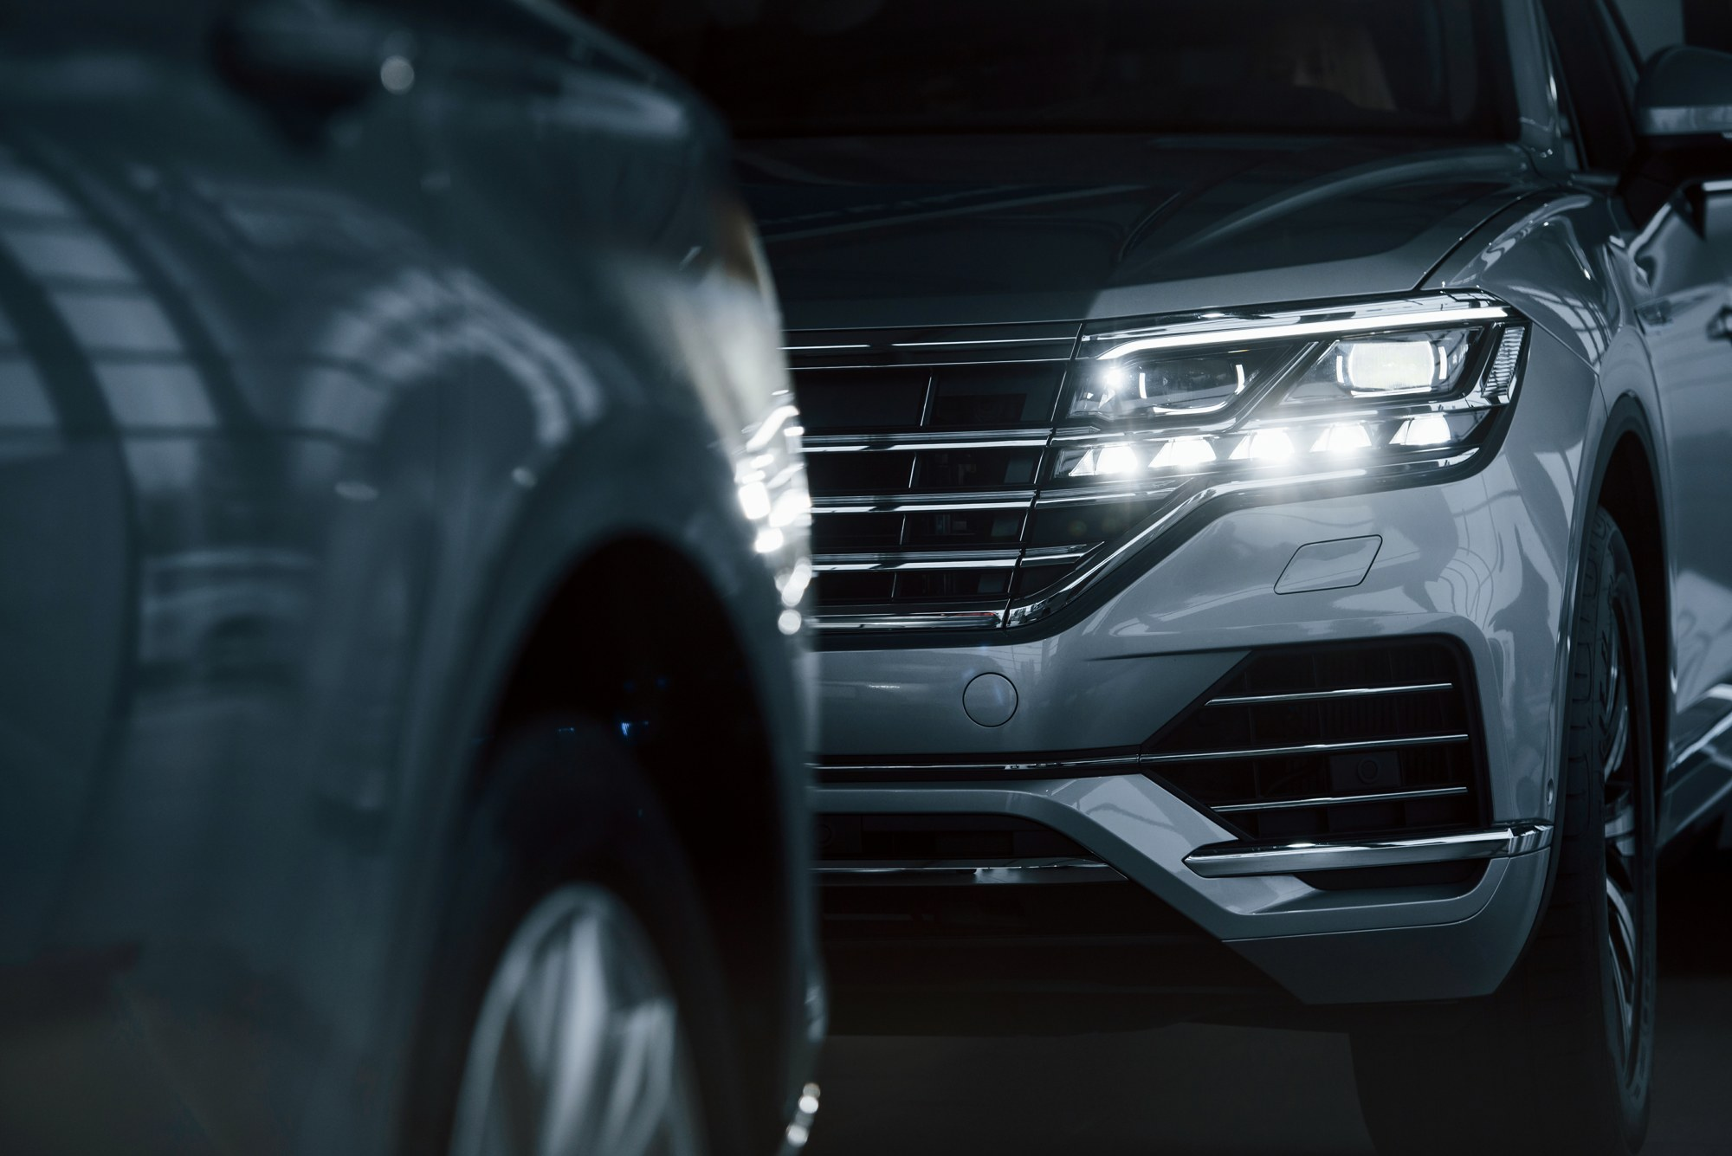
Figure 2-2: A Hot Spot Image

A carousel steps through its panels in order.
Interactivity: Narrative

First
A carousel panel pairs a picture with its copy.

Second
The learner moves through the panels with the arrows.

Third
Use it where the order matters - a sequence or a timeline.

Interactivity: Text with Popups

first popup
A popup explains a phrase without interrupting the copy.

second popup
Each panel becomes one popup, opened from its own link.

Section 2.3: Sliders, Spacer and Table
Interactivity: Graphic Slider

Stop 1: Before

Stop 2: After

Interactivity: Spacer
A spacer holds no copy; it separates the components around it.

A table asked for by name becomes a component of its own:
Interactivity: Table
Component | What the learner does
Accordion | Opens one panel at a time
Tabs | Compares parallel topics
Hot spots | Explores a picture

Section 2.4: Video
A narration table becomes a video component. The line below names the file, which is also how a Key Concepts script is asked for as a video instead of an accordion - name no file and it stays an accordion.
Video: sample.mp4, Poster: poster.png
Narration for Section 2.4 Presentation | On Screen Text
This is the voiceover script for the video. | This is what appears on screen while it plays.

Key Concepts (For Programming)
Narration for KCs Presented by Avatar | On Screen Text
Accordions, tabs and hot spots each suit a different shape of content. | Choosing an Interactivity  Accordion: topics read in any order  Tabs: parallel topics  Hot spots: exploring a picture
Carousels, popups and sliders carry sequence, detail and comparison. | The Rest of the Set  Carousel: a sequence  Popups: detail without interrupting  Sliders: before and after

Check Your Progress
Which interactivity suits a picture the learner explores?
Tabs
Hot spots
A carousel
A slider
Mark whether each component is a question or not.
Question | Not a question
X |  | Text input
 | X | Accordion
X |  | Graphic MCQ

Answers
B
Question, not a question, question

Section 2.5: Question Components
These three are authored as interactivities rather than as Check Your Progress questions, so they can sit anywhere in a chapter.
Interactivity: Graphic MCQ
Which picture is the sample figure used above?
The dark picture.
The bright picture.
Interactivity: Slider
How many components does this module show?
Scale: 1 to 20
Answer: 18
Labels: a few, all of them
Interactivity: Text Input
Which Word style becomes a page?
Heading 1 / H1

Glossary
base sample module | the course in base/Source: one sample of every component the automation can build
glossary term | a word marked in the storyboard with the Glossary item character style, shown to the learner as a popup
highlighted in boldface type | the way a glossary term appears in the copy

References
Adapt Learning. Adapt framework documentation. Accessed 2026. https://www.adaptlearning.org/
Base Source. The sample storyboard that builds the base course. 2026.

